**Landing Page**

<https://dribbble.com/shots/18957044-Social-Media-Management-Dashboard-Schedule>

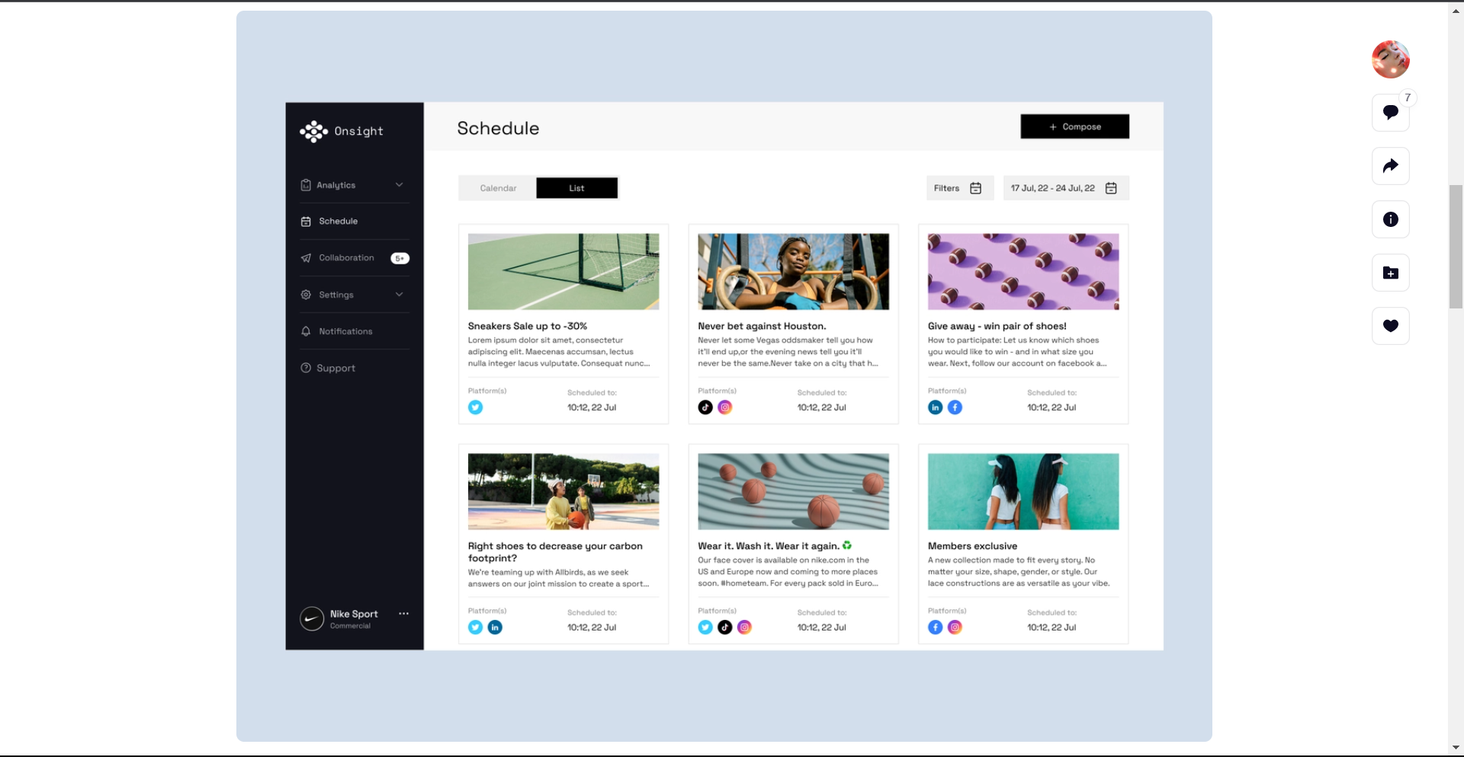

<https://www.figma.com/community/file/896378225626817891>

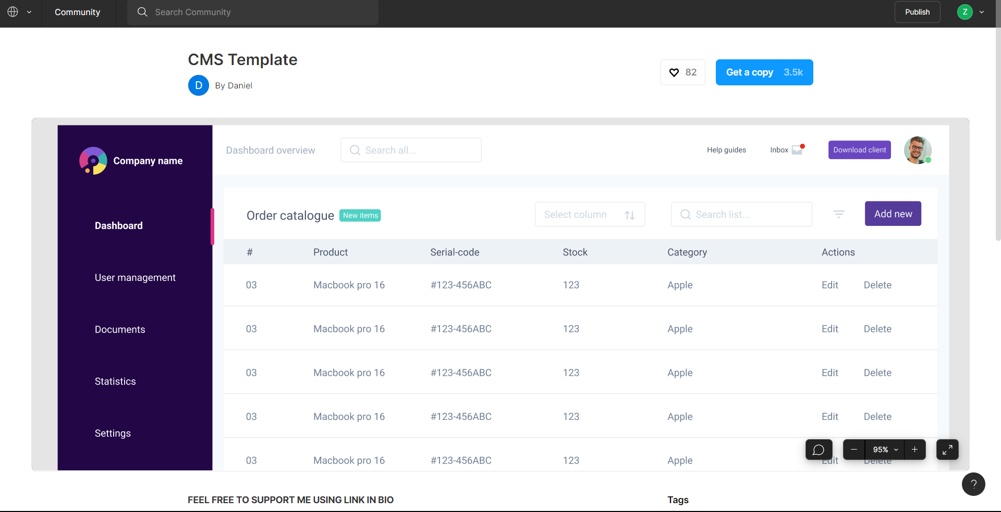

<https://www.figma.com/community/file/834872211761237129>

Login and Register

<https://codepen.io/FlorinPop17/pen/vPKWjd>